**Insight Stream: Navigate the News Landscape**

**Project Design Phase**

**Solution Architecture**

|  |  |
| --- | --- |
| Date | 11/03/2025 |
| Team ID | ID-149960 |
| Project Name | Insight Stream: Navigate the News Landscape |
| Maximum Marks | 4 Marks |

**Solution Architecture:**

The solution architecture of the News App is designed for scalability, high performance, and a smooth user experience. It ensures users get news from trusted sources while allowing personalized news playlists. The system focuses on:

* Fast and reliable news updates
* Seamless audio news delivery
* Real-time recommendations based on user interests
* Syncing across multiple devices for a continuous experience

The role involves **identifying the best tech solutions** to address existing business challenges while ensuring efficiency and scalability. It requires **defining the software's structure, characteristics, and behaviour** in a way that is clear to project stakeholders. Additionally, the role includes **outlining key features, development phases, and solution requirements**, ensuring a well-structured roadmap. Lastly, it involves **providing detailed specifications** that guide the solution's definition, management, and delivery, ensuring alignment with business goals and technical feasibility.

**Solution Architecture Diagram:**

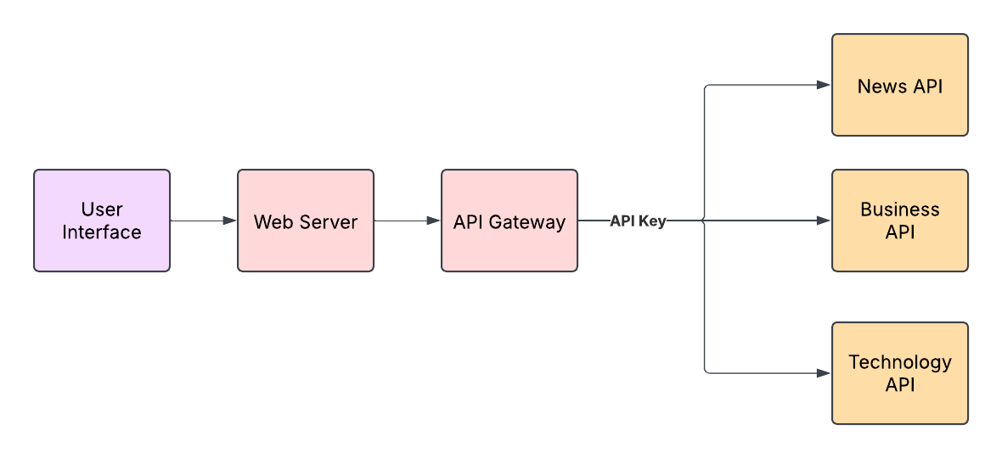

New York Times API

Gnews

API